

Automation Solutions
We Make Possible…!



◆ Nihva Technologies Automation solutions is one step solution provider for all automation needs of customer
◆ Our Mission is to provide optimized & integrated solution & services to industries using leading edge information , communication , automation & technologies .
◆ Our vision is to be a leader in the field of Automation Solutions through regular developments , quality services by meeting total customer satisfaction to help our customer to achieve their business targets by adding operational intelligences.
◆ We are determined to use leading edge technology , years of experience & knowledge in providing innovative solutions delivering High return on investments.

CONCEPTUAL
MODELING
CUSTOMER RFQ
SYSTEM MODELLING
APPROVAL FROM
CLIENT(DAP APPROVAL)
CUSTOMER REVIEW
DESIGN STRESS
ANALYSIS
FAT AT NIHVA
MANUFACTURING &
ASSEMBLY
INSTALLATION &
COMMISIONING

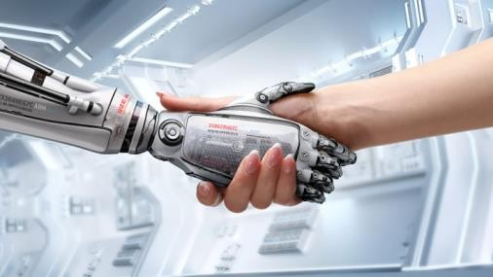
THATS THE WAY WE DO

TRAINING TO CUSTOMER & SERVICE


SYSTEM : Yes We Do Follow

ISO CERTIFICATIONS : TUV CERTIFIED ISO 9001:2015

QUALITY PRACTICES : 3C & 5S

SOFTWARE STRENGTH : SOLID WORKS 2016
AUTOCAD 2016LT


- Seconadry packaging machine.
  - Pouch into box.
  - Pouch into bag.
  - Pouch into pouch.
  - Bottle into film . 2.Plant automation solution. 3.Robitic application. 4.Dairy automation.
- Case erector.
- Case tapping machine. 7.Palletizing Automation.
  - Robotic palletizing.
  - Gantry palletizing.
  - Level palletizing.
  - Pallet dispenser. 8.Conveyor traffic management. 9.Gantry system. 10.Conveyors.

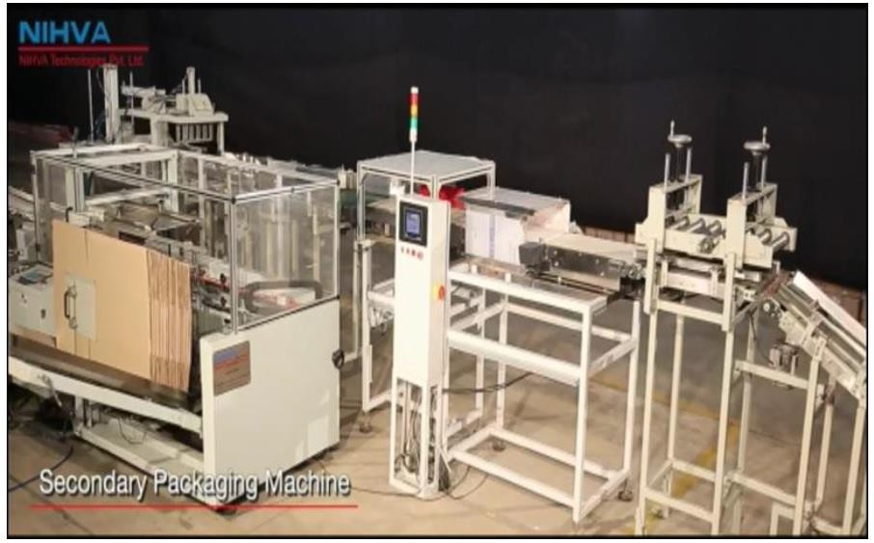
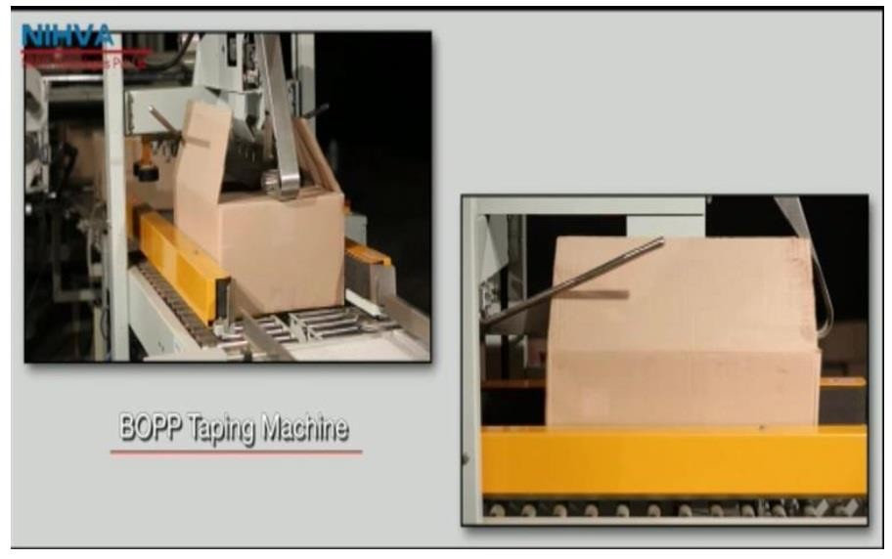

1.Seconadry packaging machine


1.1 Pouch into box

Features: 1.Online pouch counting.
2.Online Weight measurement. 3.Online matrix formation.
4.Safety . 5.More efficient.
6.Eliminate labor cost. 7.Environmental friendly.

Nihva
automation
manufacturing
pouch
into
box
secondary packaging machine.
These machine are used in Food , Pharma, dairy & other
related industries.
All such type of machines are custom based as per requirement. We provide online counting of pouches , making online pouch matrix, Online box making, box filling by pouches, online taping of box
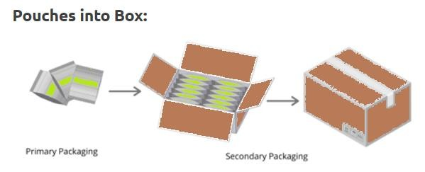

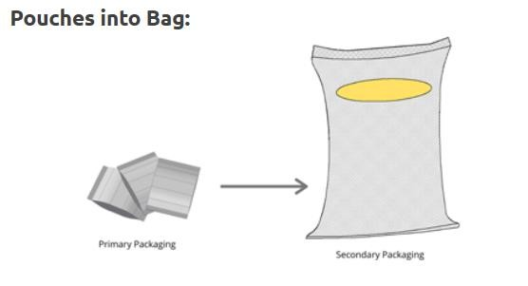
1.2 Pouch into bag.
Nihva automation manufacturing pouch into bag secondary packaging machine.
These machine are used in Food , Pharma, dairy, seeds, tobacco, fertilizer, animal foods related industries. All such type of machines are custom based as per requirement. We provide online counting of pouches , making online pouch matrix, Online bag mouth opening, bag filling by pouches, online stitching of bag and weighing of bag.
Features: 1.Online pouch counting.
2.Online Weight measurement. 3.Online matrix formation.
- Safety .
- More efficient. 6.Eliminate labor cost. 7.Environmental friendly.

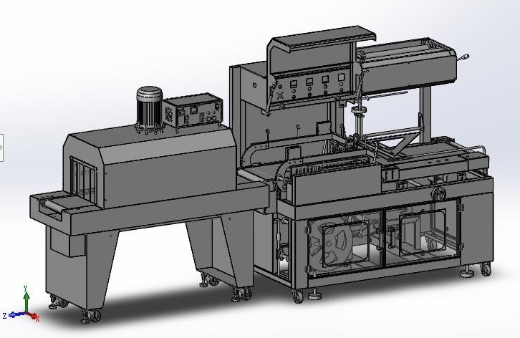Nihva automation manufacturing pouch into pouch secondary packaging machine.

Features: 1.Online pouch counting.
- Online Weight measurement.
- Online matrix formation. 4.Safety .
5.More efficient. 6.Eliminate labor cost. 7.Environmental friendly.
These machine are used in Food , Pharma, dairy, seeds, tobacco, animal foods related industries. All such type of machines are custom based as per requirement. We provide online counting of pouches , making online pouch matrix, Online film feeding, Film cutting and sealing, Wrapping of film by shrink tunnel.
1.3 Pouch into pouch

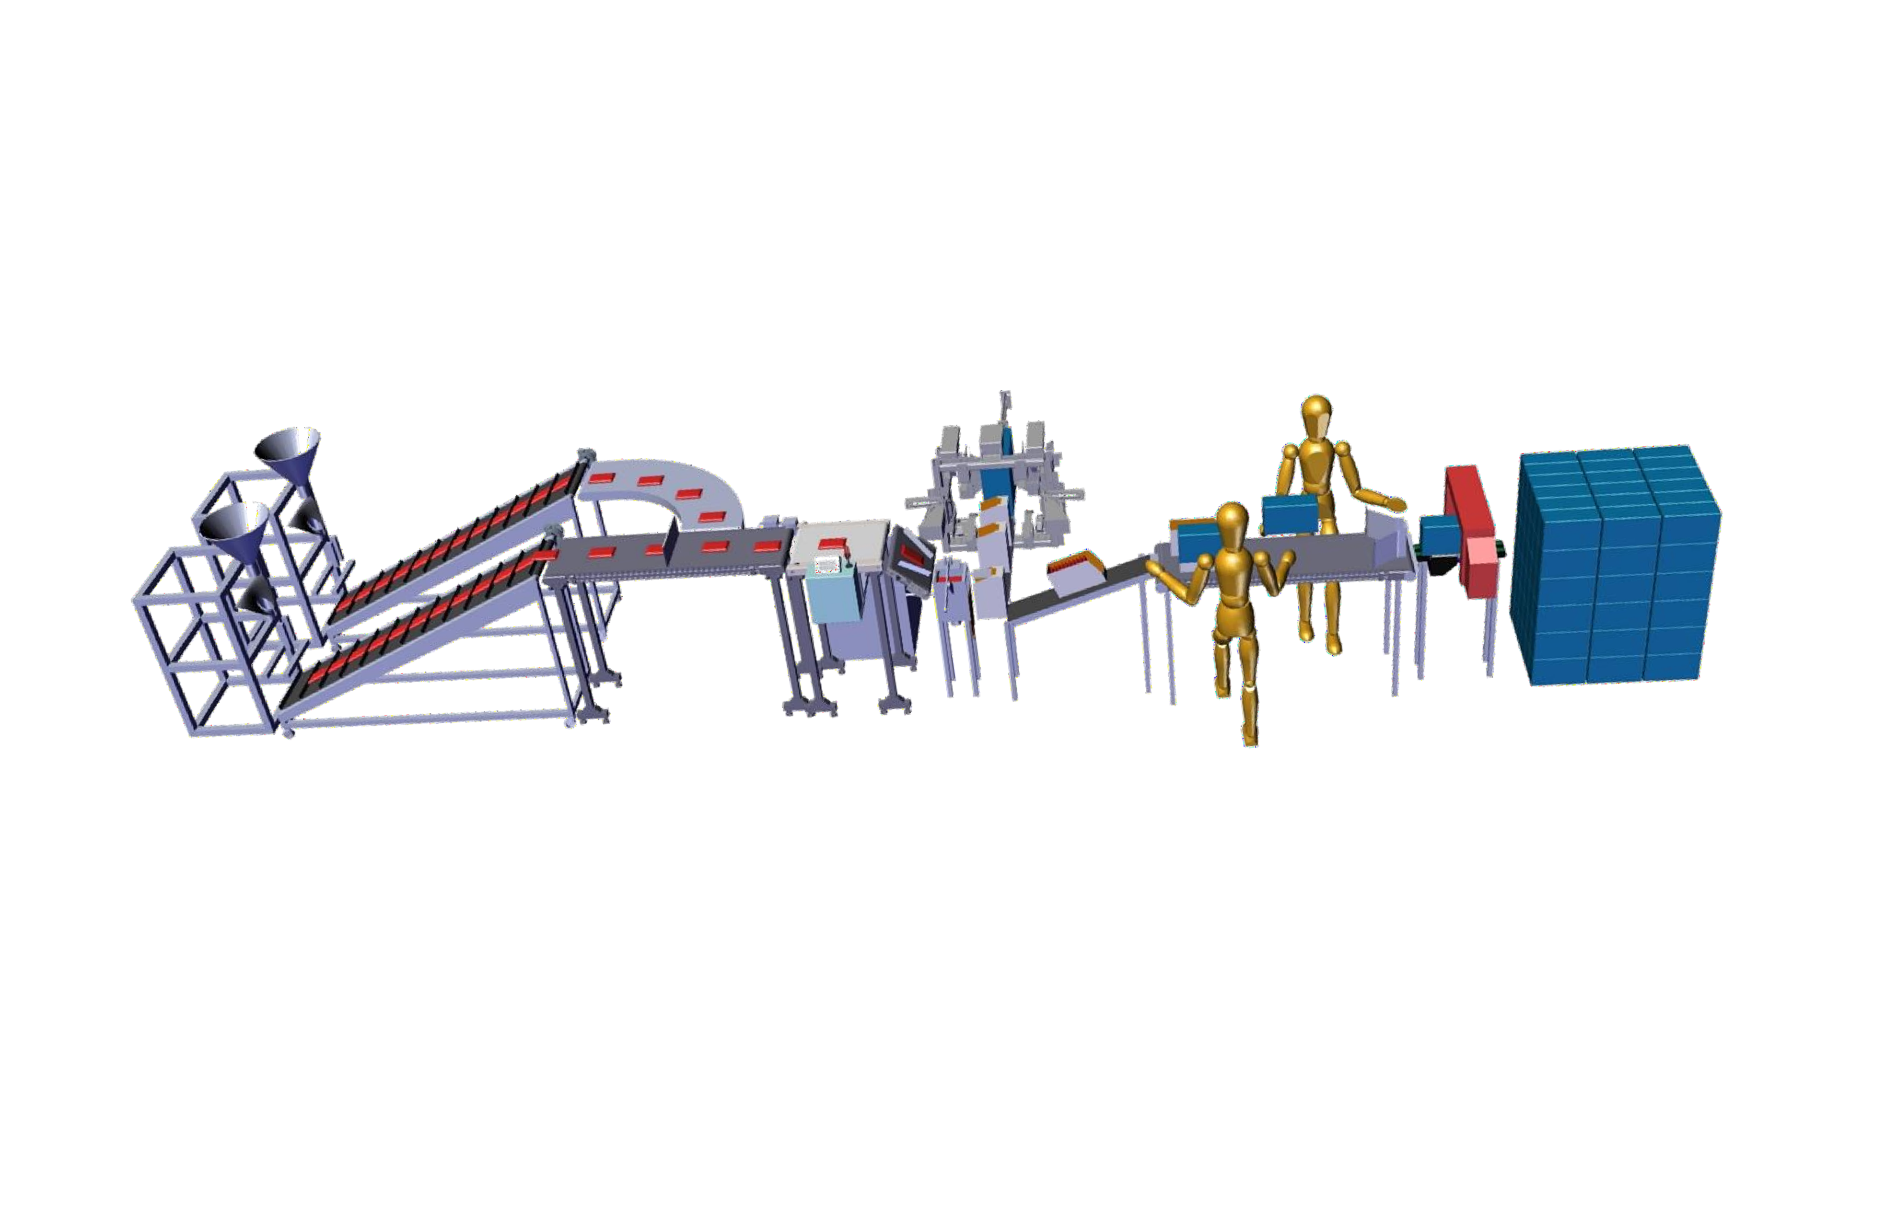


2.Plant automation solutions:

- Plant automation solutions are the solutions where complete plant material is handled by automatically specially in food , pharma, animal food, cement industries, seed industries, Fertilizer industries, Etc.
- Which include secondary and tertiary packaging machine, conveying line and many more machines included in plant automation.

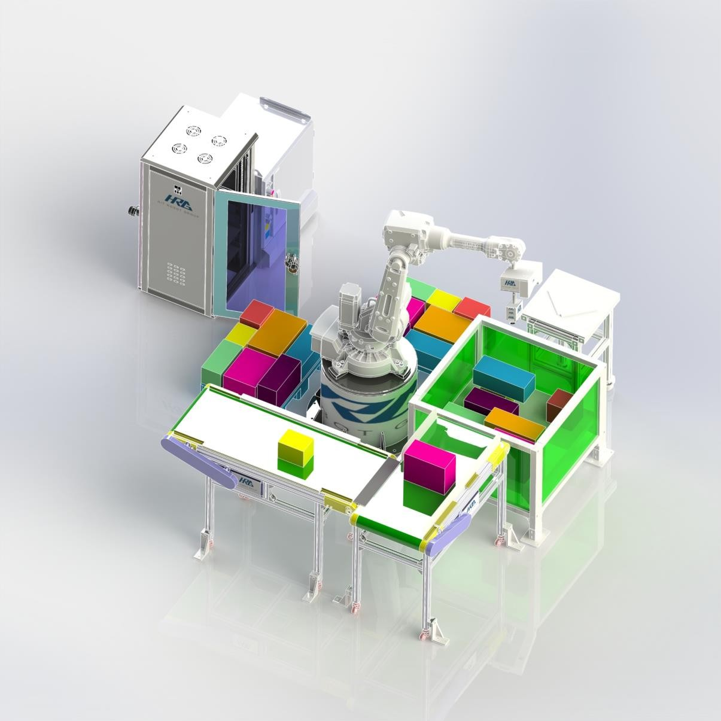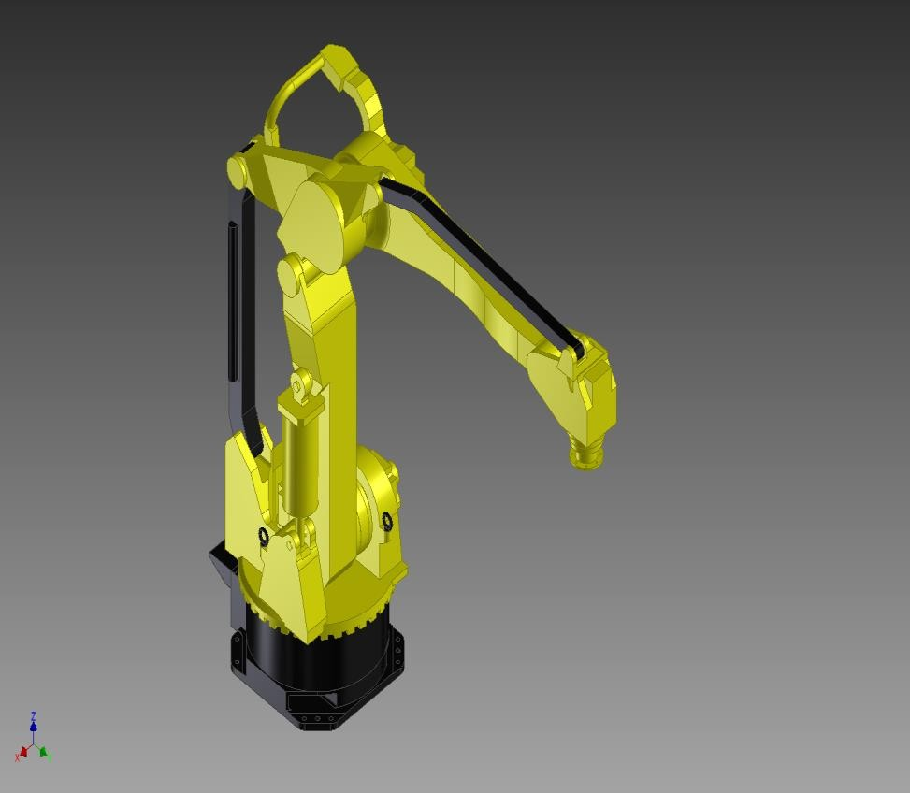
We are solution provider for various robotic application. By robot we can do following activities.
1.Bag matrix formation. 2.Pouch matrix formation. 3.Crate matrix formation. 4.Palletizing of bag, pouch, box. 5.Sorting of product.
6.Pick and place application can be done.

3.Robotic application


4.Dairy automation

4.Vertical lift conveyor:-
  - It is used for conveying in small space
  - It is used for conveying Crates & bags.
  - 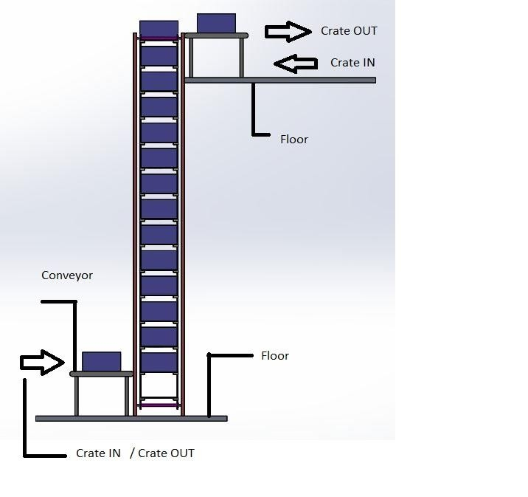It can be moved C shape, Z shape.
  - It can carry various products up to 600 kg(total).
  - Size of conveyor is designed as per requirement.
  - For dairy , food & pharma industries we can use
  - Easy to clean ,
  - Easy to maintain.
  - Easy to replace clits as it is modular.
  - It comes in PVC modular belt and chain.
  - Sizes of conveyor is as per requirement.


5.Case erector

c
Case erector.
  - Case erector is used for forming of case blank
to formed case.
  - Labeling of bottom tape.
  - Size of the carton up to 600mm L x 500mm W x 400 mm H.
  - No of carton /min-10 pc/min.
  - 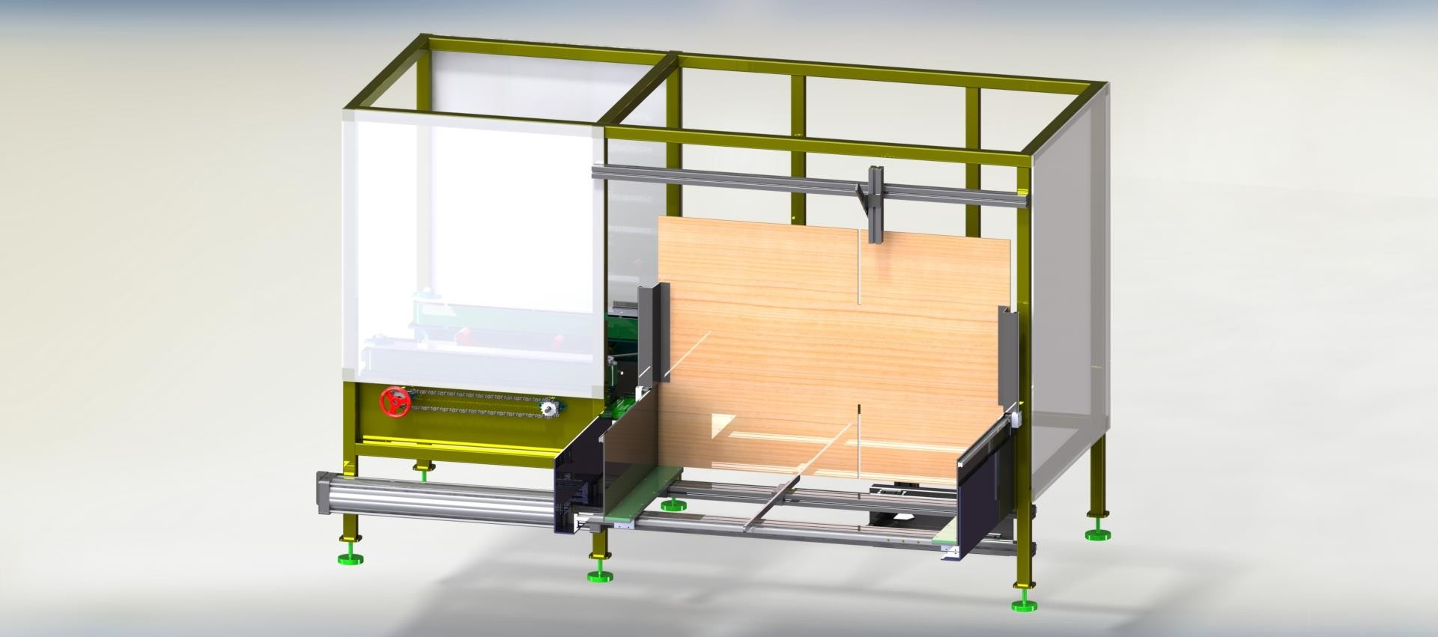Length , width and height is adjustable.
  - Fully automated machine.

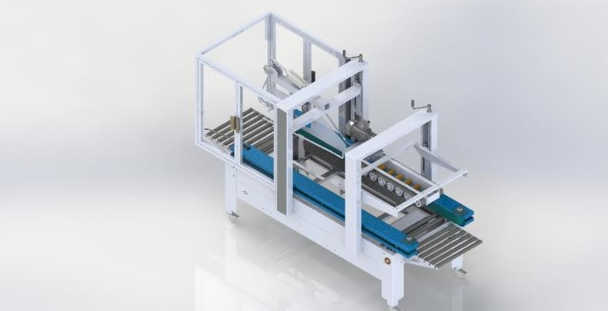
Case tapping machine.
6.Case tapping machine
- Case tapping is used for pasting of tape on top side of formed case.
- Labeling of top tape.
- Size of the carton up to 600mm L x 500mm W
x 400 mm H.
- No of carton /min-10 pc/min.
- Length , width and height is adjustable. 6.Fully automated machine.
- Width of tape 50mm, 75mm, 100mm.


7.Palletizing automation

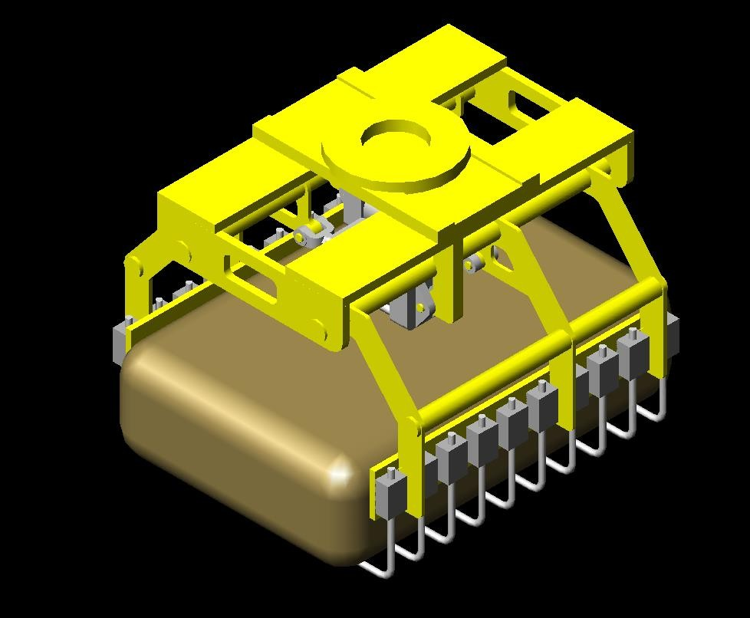Robotic palletizing.
7.1 Robotic palletizing
  - We supply and integrate robotic palletizing
and de-palletizing system.
  - 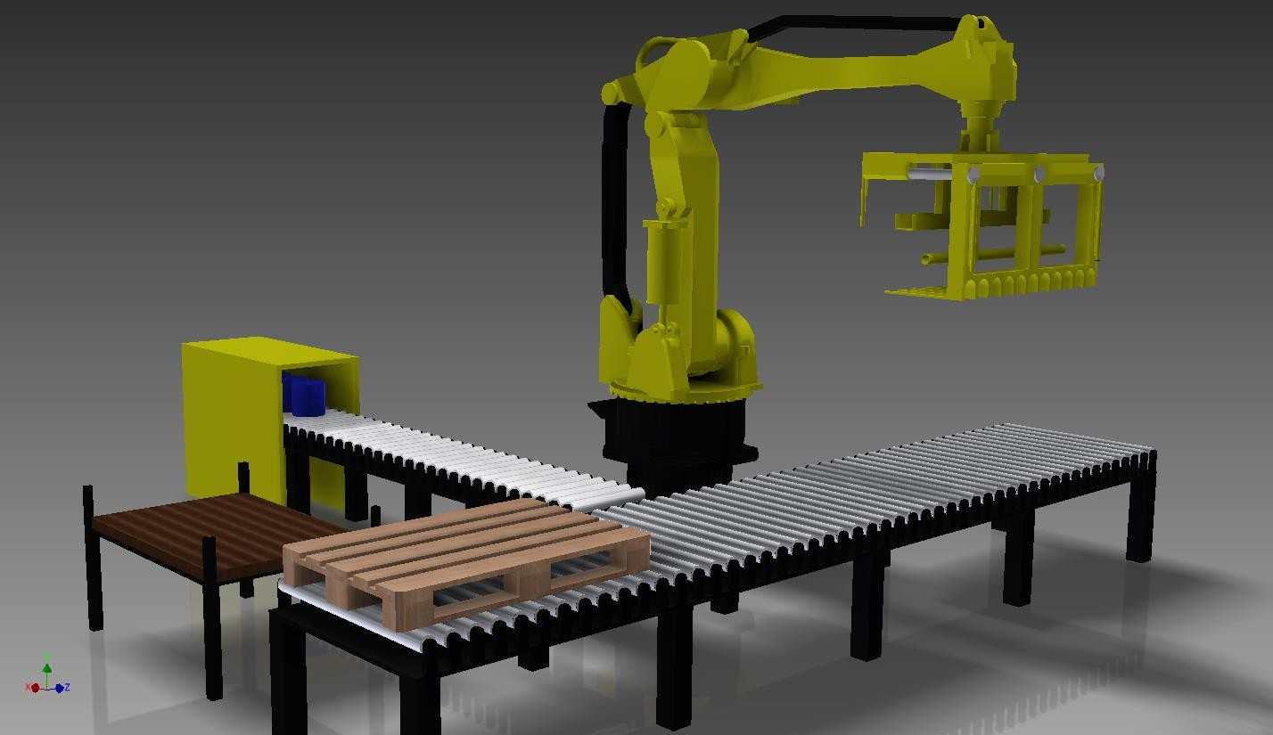It is used for Box, bag, bottle, tin &buckets 3.This type of application can save lot of time with accuracy.
4.Can be customized to any height to any weight.

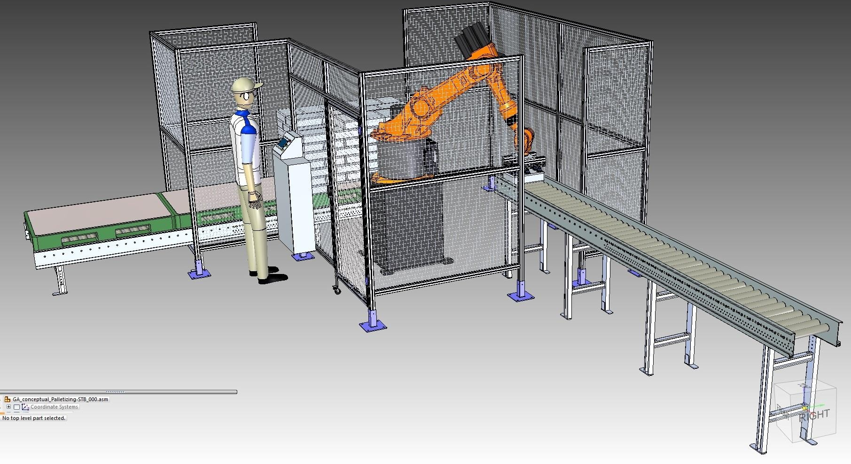

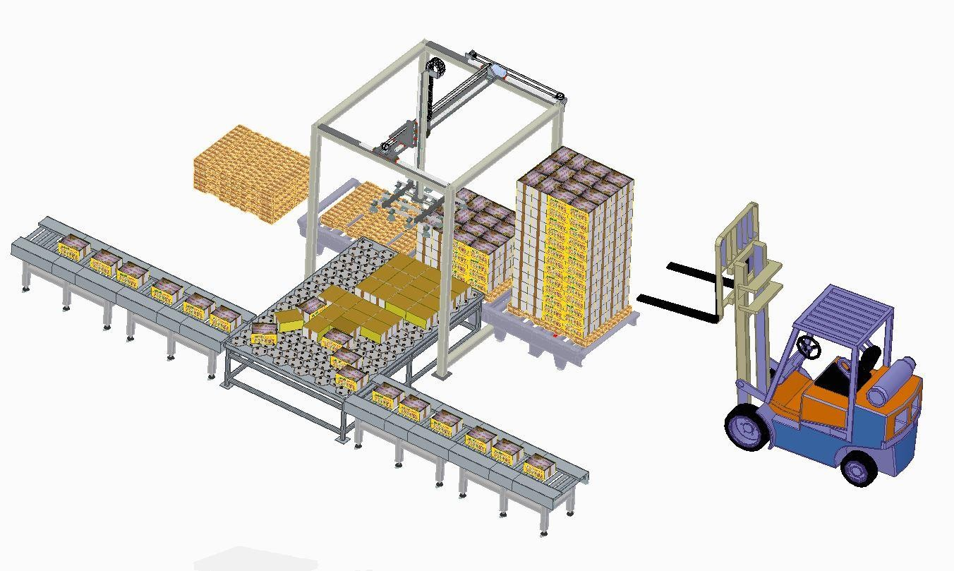7.2 Gantry palletizing

Gantry palletizing.
- We supply and integrate gantry palletizing and de-palletizing system.
- It is used for Box, bag, bottle, tin &buckets 3.This type of application can save lot of time
, space, and money.
- Can be customized to any height to any weight.
- This is low cost and robust technology.

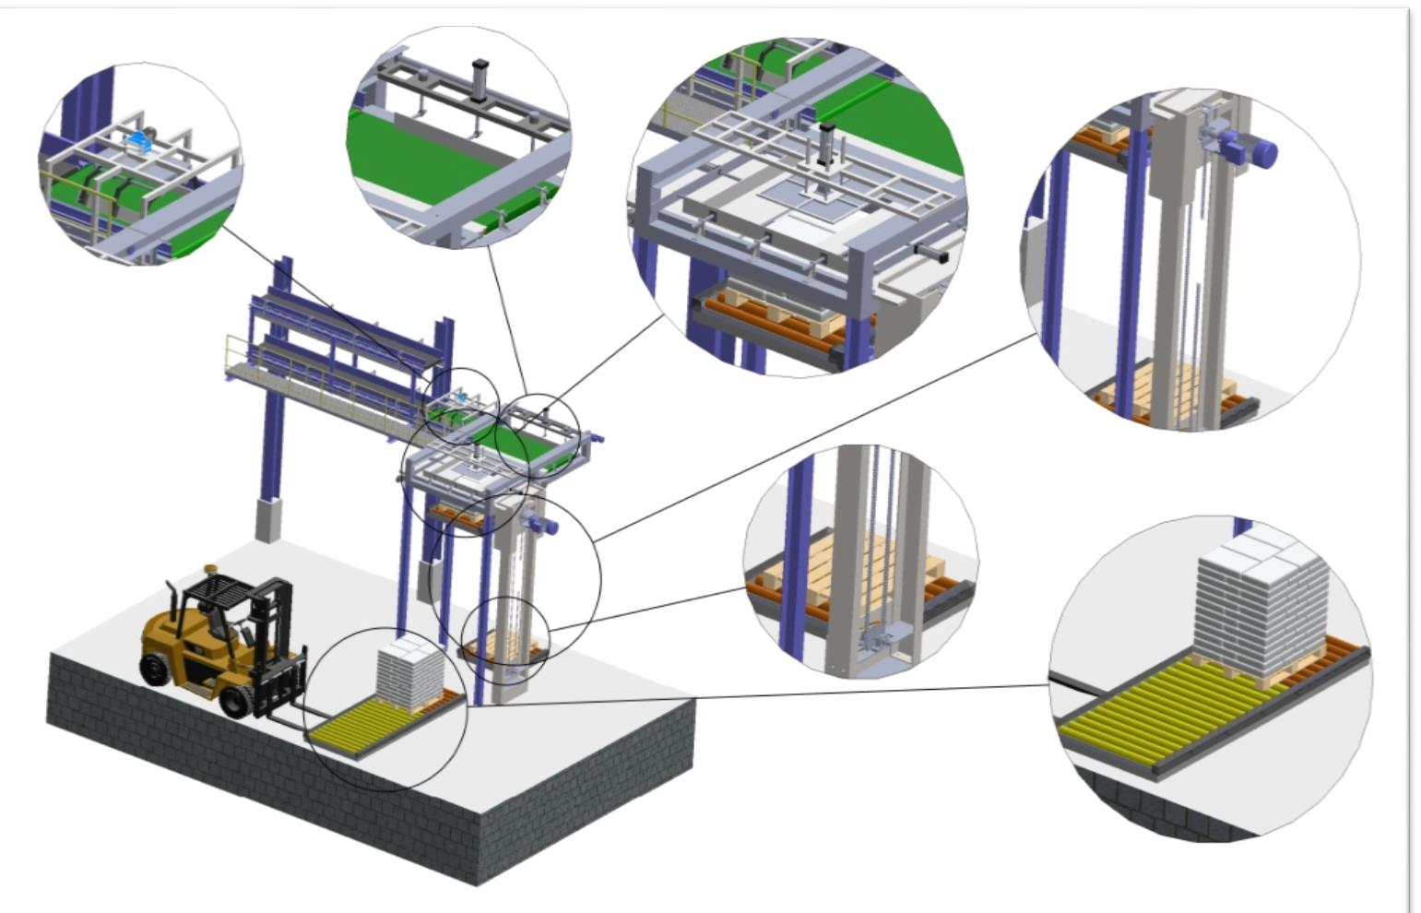


7.3 Layer palletizing

Layer palletizing.
  - It is low cost solution of palletizing
  - It is used for Box, bag, bottle, tin &buckets 3.This type of application can save lot of time with accuracy.
- Can be customized to any height to any weight.
- It is overhead type.


8.Conveyor traffic management

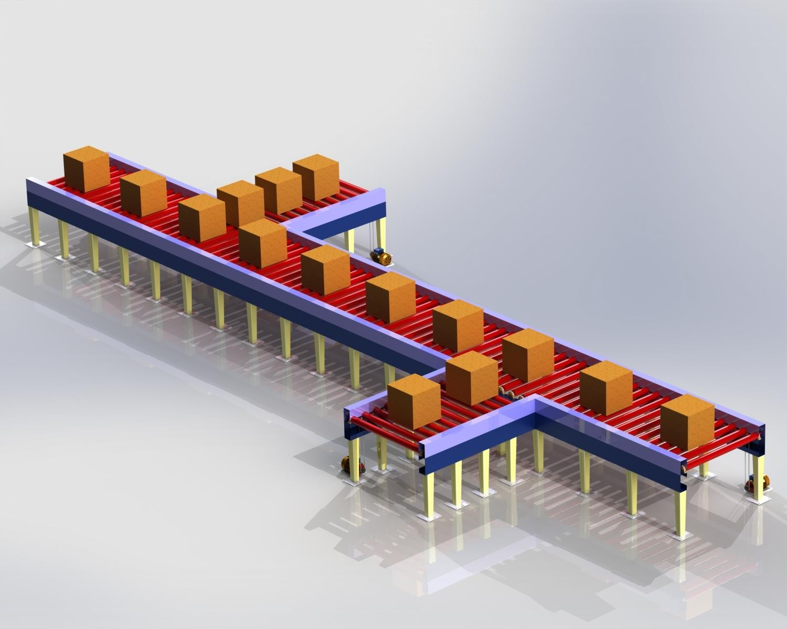Conveyor traffic management.
  - In this no. of conveyors are connected to
express conveyor.
  - Traffic management is works on sensors. 3.It is used for Box, bag, bottle, tin &buckets 4.It is tailor made conveyors.


9. Gantry system.

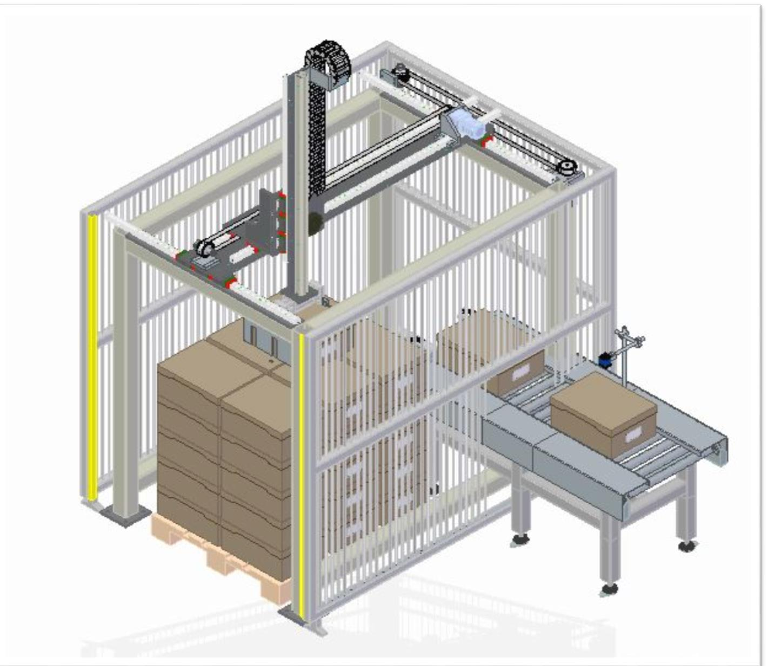Gantry system
- It is used for pick and place at X,Y&Z axis with
rotation.
- It is used for Box, bag, bottle, tin &buckets. 3.This is works on servo motors.
4.Can be customized to any height to any weight. 5.This is low cost and robust technology.



10.Material handling conveyors.

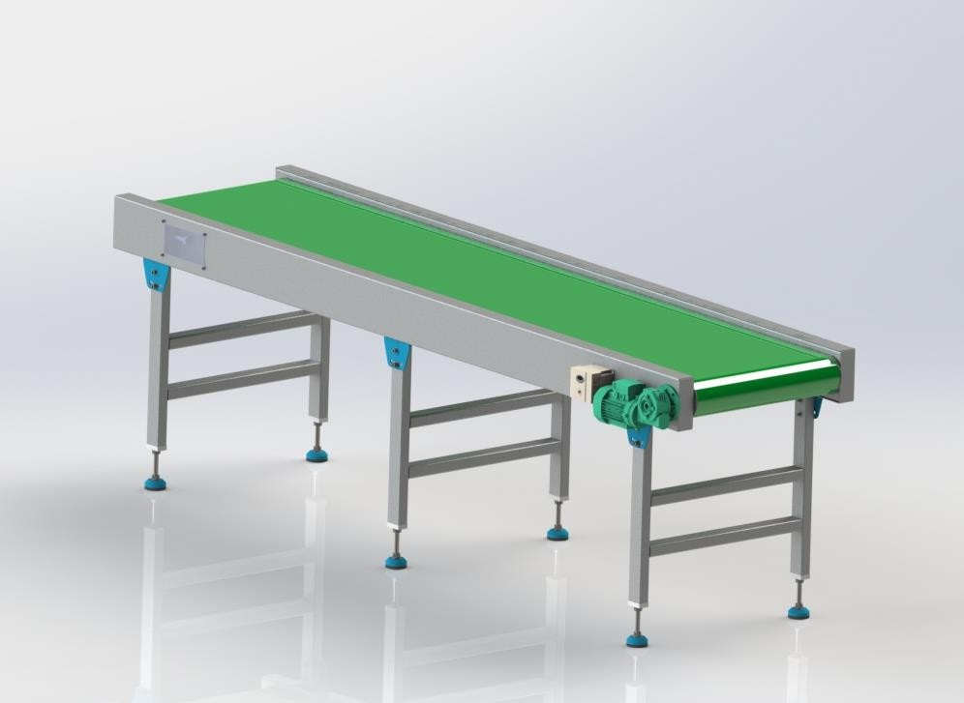

Flat belt conveyor.

Flat belt conveyor:-
- It is used for manual packaging.
- It is used for printing and labeling.
- It is used for inspection purpose.
- It can carry various products up to 100 kg.
- Size of conveyor is designed as per requirement.
- For food and pharma industries we can use it.

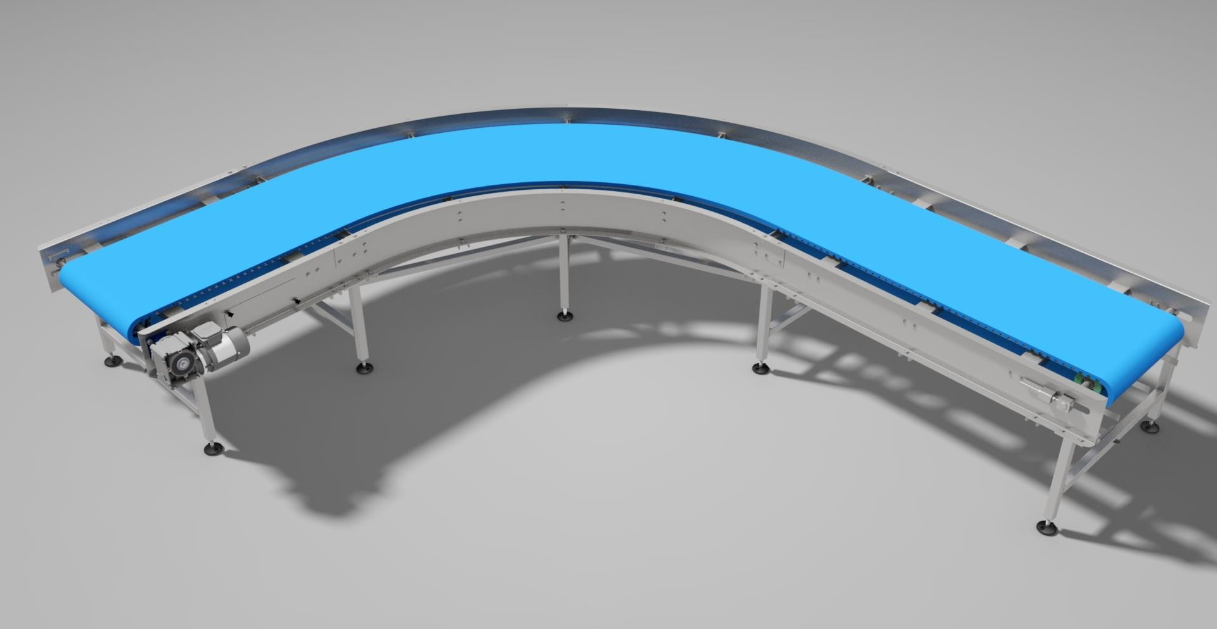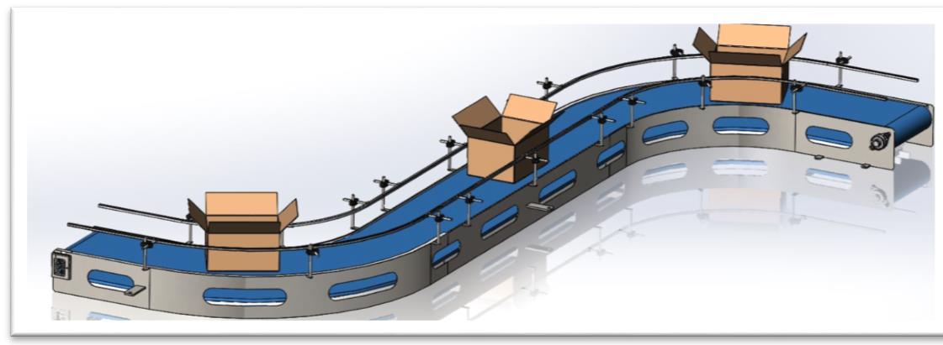90 deg. Conveyor.
90 deg. conveyor:-
- It is one of the simplest conveyor.
- It is used for conveying crates, box, pouches &
bags.
- It can be moved 90 deg, 180 deg, 270 deg .
- It can carry various products up to 100 kg.
- Size of conveyor is designed as per requirement.
- For food and pharma industries we can use it.
- Easy to clean ,
- Easy to maintain.
- Easy is replace belt as it is modular.

Inclined and declined conveyor:-
Inclined & declined conveyor
  - It is used for conveying inclined and declined material handling.
  - It is used for conveying pouches & bags.
  - It can be moved L shape, Z shape.
  - It can carry various products up to 50 kg.
  - 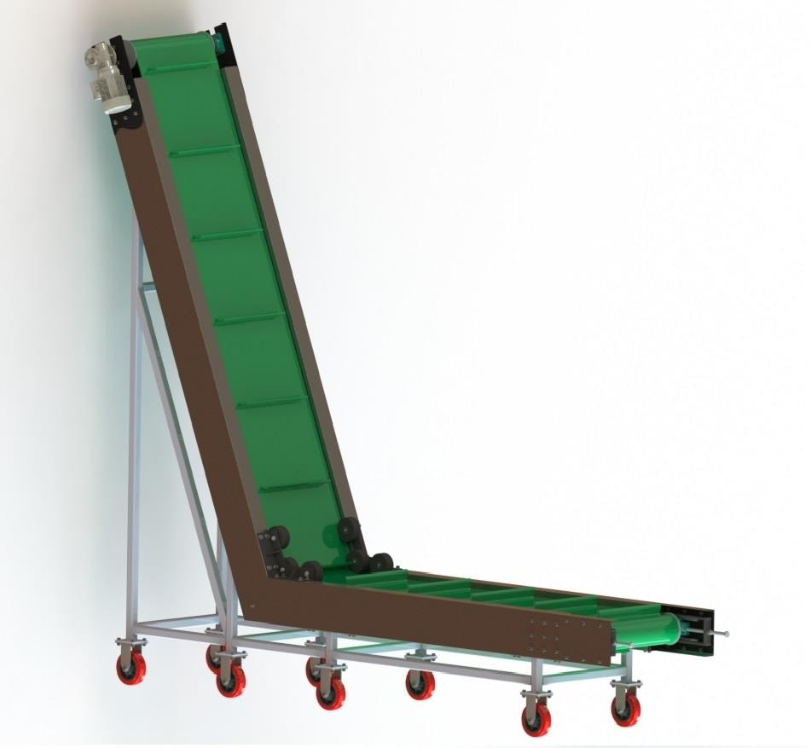Size of conveyor is designed as per requirement.
  - For food and pharma industries we can use it.
  - Easy to clean ,
  - Easy to maintain.
  - Easy is replace belt as it is modular.
  - It comes in PU/PVC belt and modular belt.
  - Sizes of conveyor is as per requirement.

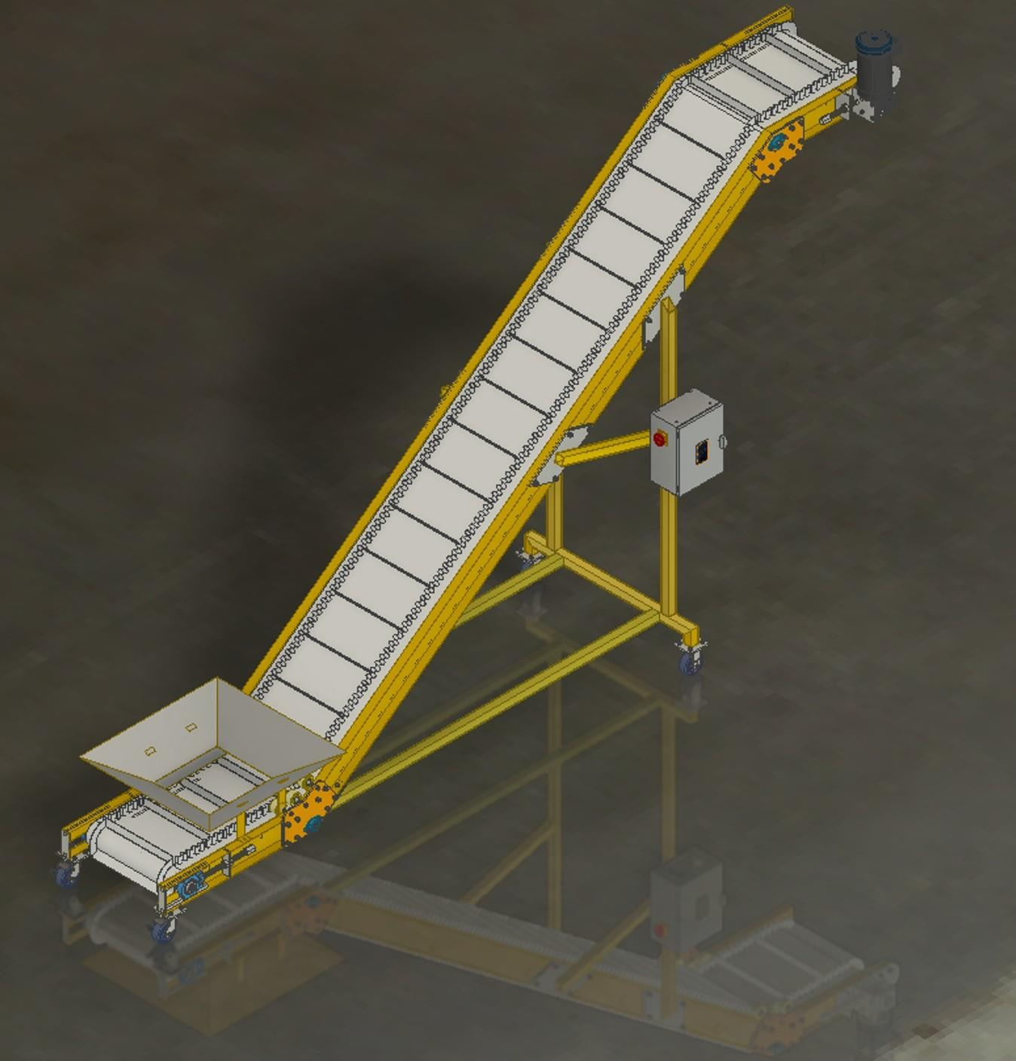

Acclivitous conveyor

Acclivitous conveyor:-
- It is one of the simplest conveyor.
- It is used for conveying Namkeen, granules, grains & many more.
- It can be moved L shape and Z shape .
- It can carry various products up to 25 kg.
- Size of conveyor is designed as per requirement.
- For food and pharma industries we can use it.
- Easy to clean .
- Easy to maintain.
- Easy is replace belt as it is modular.

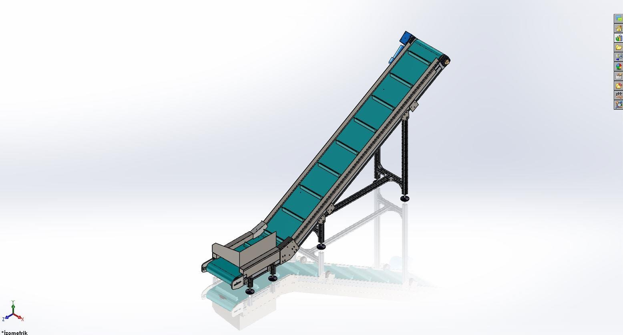

Take up conveyor

Take up conveyor:-
- It is used for conveying inclined material handling.
- It is used for conveying pouches & bags.
- It can be moved L shape, Z shape.
- It can carry various products up to 50 kg.
- Size of conveyor is designed as per requirement.
- For food and pharma industries we can use it.
- Easy to clean ,
- Easy to maintain.
- Easy is replace belt as it is modular.
- It comes in PU/PVC belt and modular belt.
- Sizes of conveyor is as per requirement.

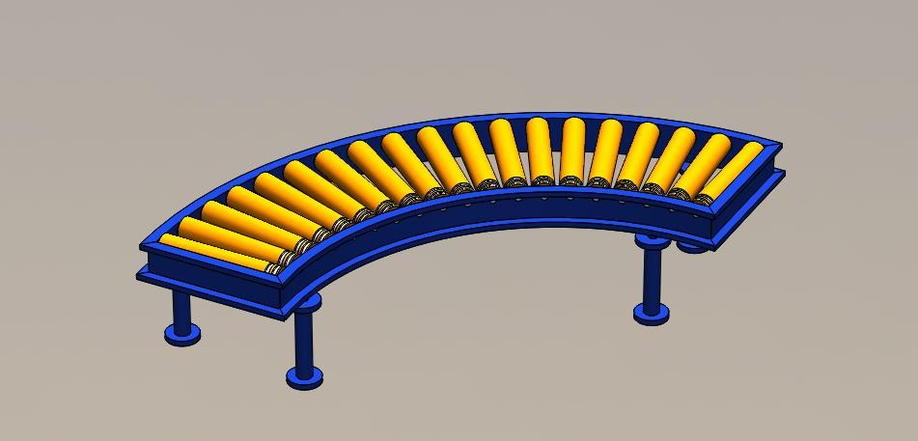

Drive 90 deg roller conveyor

Drive 90 deg. conveyor:-
  - It is one of the drive roller conveyor.
  - It is used for conveying crates, box in 90 degree.
  - It can be moved 90 deg, 180 deg, 270 deg .
  - It can carry various products up to 100 kg.
  - Size of conveyor is designed as per requirement.
  - For any industries we can use it.
  - Easy to clean ,
  - Easy to maintain.
  - Easy is replace roller as it is modular.

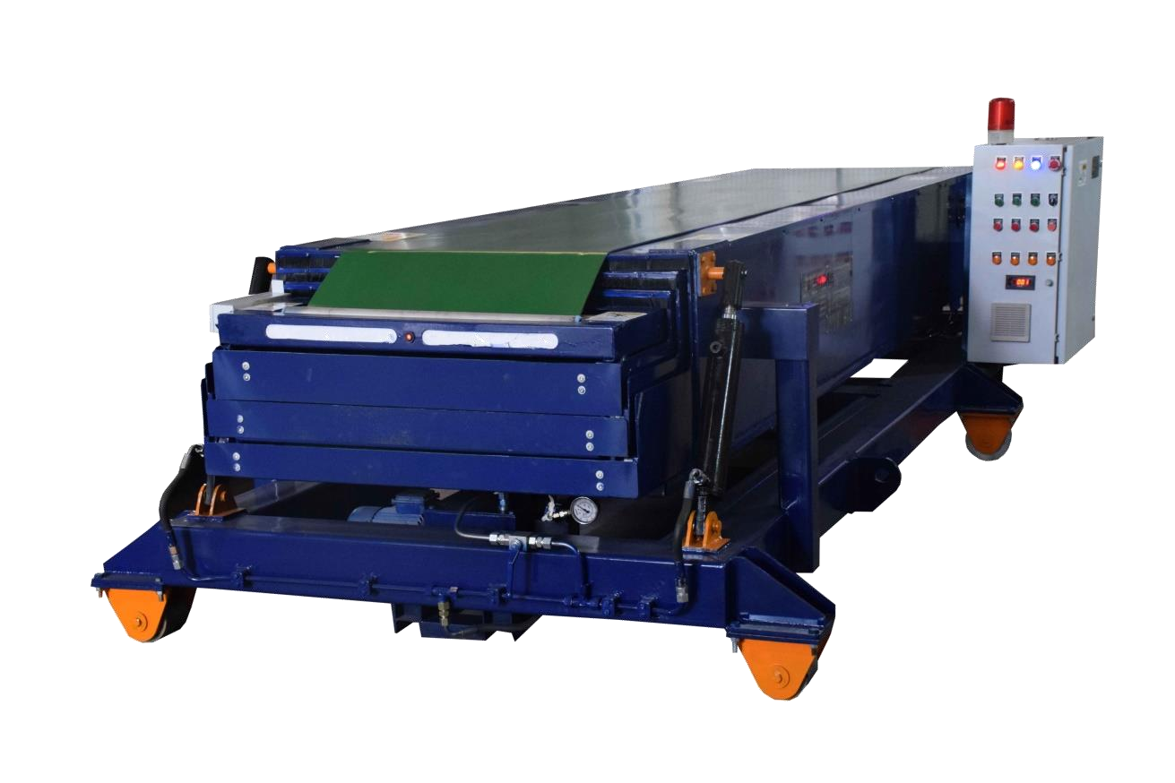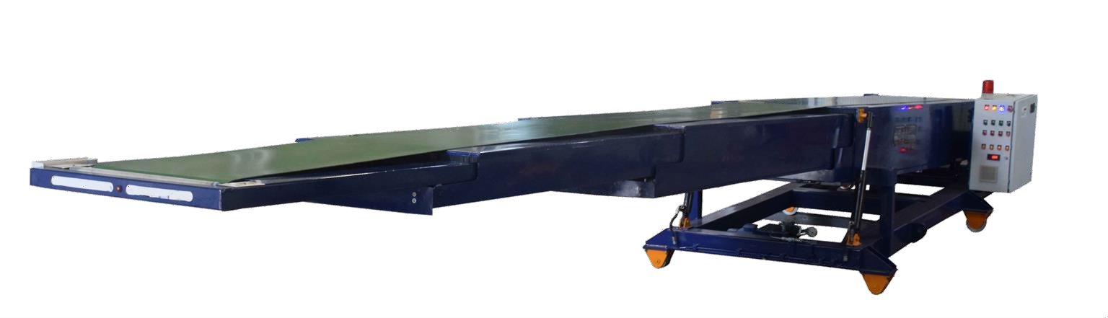Telescopic conveyor

Telescopic conveyor
- It is used for loading and unloading vehicle.
- Products can be moved bag , box , etc
- It saves lot of time in loading and unloading.
- It can manufactured as per requirement.
- Robust design .
- For any industry it is useful.

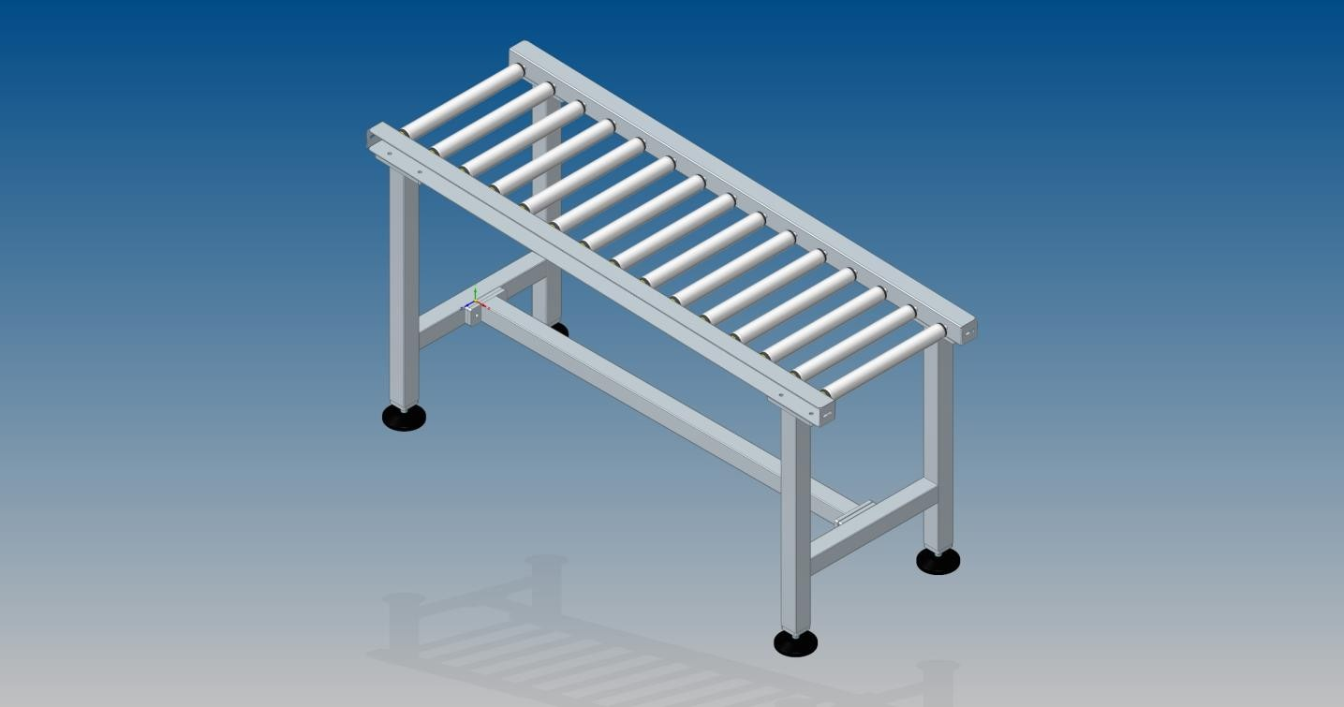
1.Gravity roller conveyor:-
- It is one of the gravity roller conveyor.
- It is used for conveying crates, box
- It can be moved 90 deg, 180 deg, 270 deg .
- It can carry various products up to 100 kg.
- Size of conveyor is designed as per requirement.
- For any industries we can use it.
- Easy to clean ,
- Easy to maintain.
- Easy is replace roller as it is modular.
7.Gravity roller conveyor.

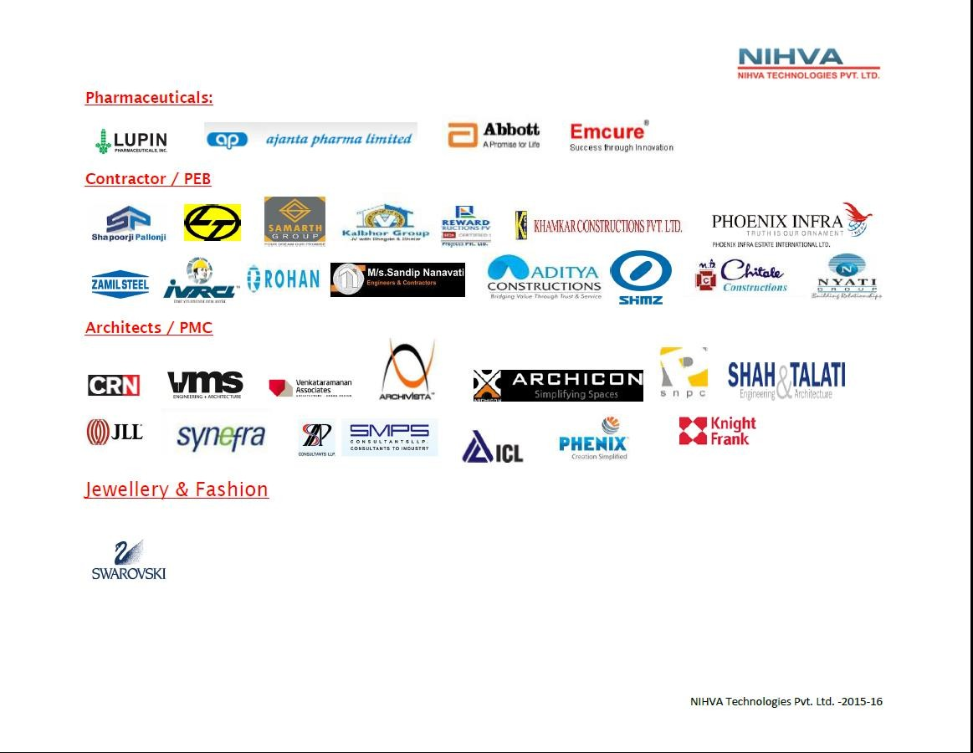

Thank you



